Evi Fitriya – 1201222005

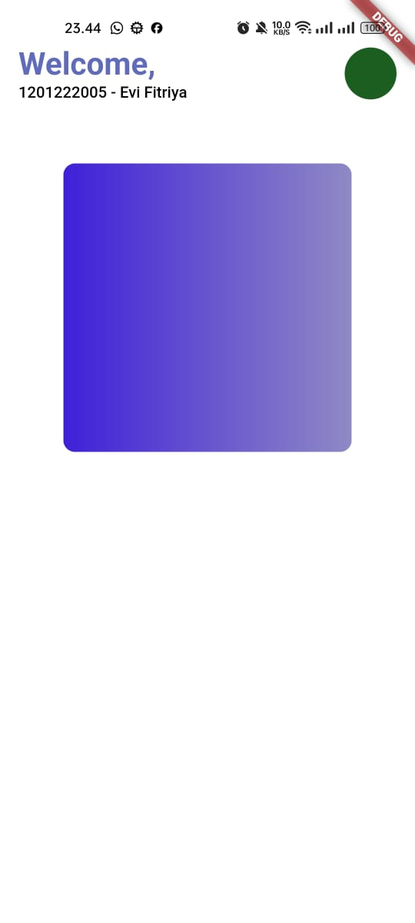Tampilan :

Kode :  
<https://github.com/evftrya/Mobile_Programming_Course/tree/main/praktikum_1/lib>